P.O Box 26083 Kampala, Uganda
Telephone: 0703999220, +256 393 277 640
Email wentzmc@africarenewal.org
Plot 22 Ggaba, Kawuku Road

Gaba Community Health Project (GCHP)
Health access for the urban poor project report: January to September 2020
Project Name | Health Care Access | Reporting Date | 16 October 2020
Project Manager | Sarah Komugisha | Reporting Period | January - September 2020
Project Location | Kisenego & Katoogo | Project Funders | World Water

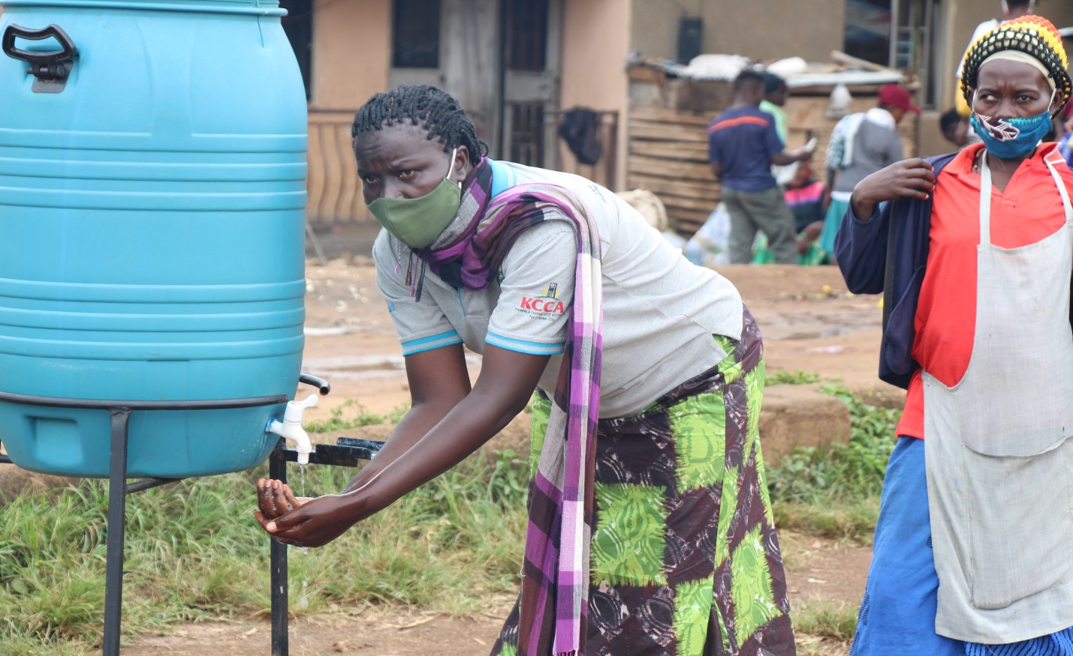

Hand washing before accessing healthcare during outreaches.

Project background
The main aim of Healthcare Access Project is to provide free healthcare services and health education to the urban poor in the communities of Katoogo and Kisenego which will in turn leads to a reduction of morbidity and mortality rates among the population of Katoogo and Kisenego.
The project specifically seeks to do the following:
- To provide medical treatment to the urban poor through community based outreaches.
- To provide health education to people of Katoogo and Kisenego to enhance health literacy and public health awareness.
- To provide interventional care through the Patient Assistance fund (PAF) to patients who need more medical attention other than that provided during the camps.
- To maintain a vibrant and effective Village Health Team as core of our prevention strategy in combating preventable diseases in the communities.
- To partner with the local Churches for Christian witnessing during the outreaches.
Summary of Project Output:
Key Area | Project Output
Childhood Immunization | 1003 babies were immunized during this period.
Distribution of deworming tablets & Vitamin A | 482 Children given deworming tablets & 356 children given Vitamin A
Capacity Building for VHTs | Three trainings were conducted.
Community based Medical Outreaches | 1,207 people received different medical care services.
Family Planning | 203 people utilized family planning services.
Patient Assistance Fund (PAF) | 218 patient visits were registered under PAF
Cervical cancer screening | 67 women were screened for cancer on Women’s day.  Positive: 04, Negative:63

- Childhood Immunization,
The purpose of these outreaches is to increase access and utilization of immunization services .Immunization not only reduces the incidence of vaccine preventable diseases but also reduces the social and economic burdens of these diseases on the communities.

Immunization Summary: Vaccine doses
Months | BCG | Polio | DPT | IPV | PCV | Rota | Measles | Vitamin A | Deworming tablets
January | 14 | 90 | 85 | 31 | 78 | 50 | 19 | 45 | 30
February | 13 | 68 | 54 | 16 | 54 | 38 | 12 | 48 | 38
March | 9 | 59 | 49 | 19 | 45 | 44 | 15 | 32 | 24
April | 13 | 55 | 58 | 13 | 57 | 34 | 21 | 35 | 25
May | 11 | 65 | 46 | 12 | 46 | 41 | 9 | 46 | 35
June | 11 | 59 | 46 | 20 | 46 | 30 | 13 | 19 | 13
July | 14 | 78 | 65 | 20 | 62 | 42 | 25 | 55 | 252
Aug | 13 | 69 | 57 | 16 | 57 | 40 | 09 | 22 | 13
Sept | 12 | 69 | 58 | 18 | 58 | 38 | 12 | 54 | 52
Total | 110 | 612 | 518 | 165 | 503 | 357 | 135 | 356 | 482

- Community based Medical Outreaches
A total of 1,207 people received medical services through these outreaches. We have carried out integrated outreaches comprising of family planning, voluntary counseling and testing and dental services. In these outreaches, 82 people received dental services, 905 were screened for HIV, with 46 found HIV positive and were all enrolled in the HIV Clinic.
Patients’ summary for outreaches
No. | Description | Totals
1 | Total number of patients seen | 1,207
2 | Number of Females | 854
3 | Number of Males | 353
4 | Children under the age of 5 years | 246
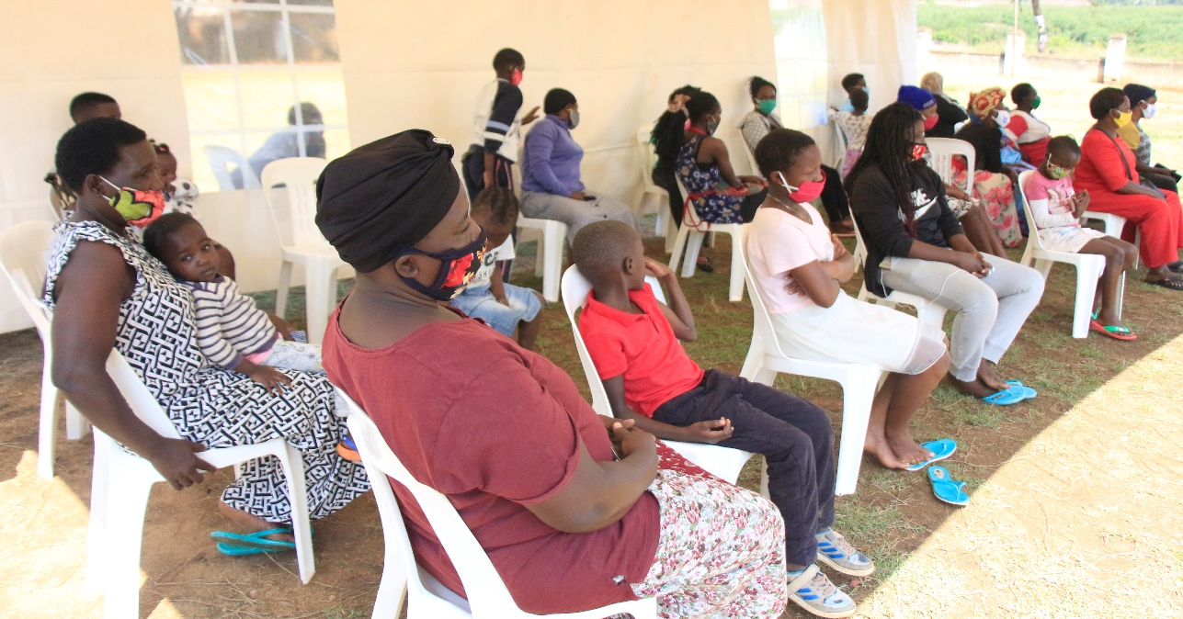
Waiting area for a medical outreach in Kisenego
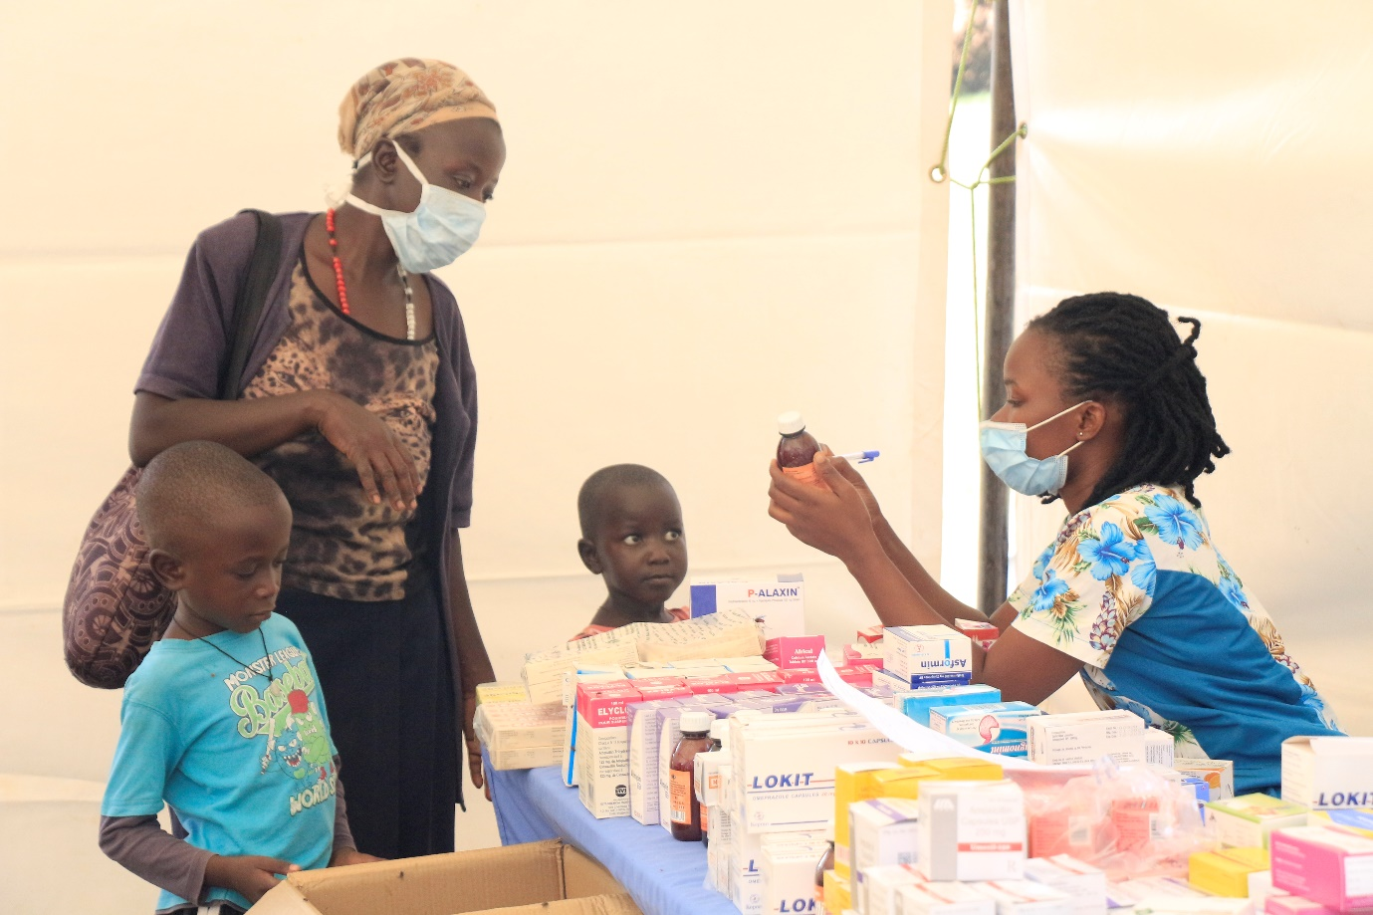
A nurse explaining a prescription for a parent during a Kisenego Medical Outreach.
- Patient Assistance Fund (PAF)
A total of 218 patient visits were recorded through this fund during this reporting period. The effects of COVID 19 lockdown continue to make PAF a lifesaving mechanism. We registered increased patient visits through PAF between April and August due to COVID lockdown guidelines which suspended medical outreaches so patients were directly referred by VHTs to Wentz medical center.
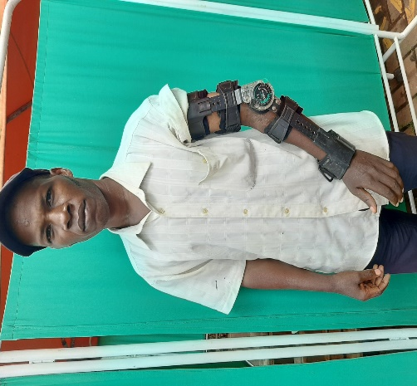
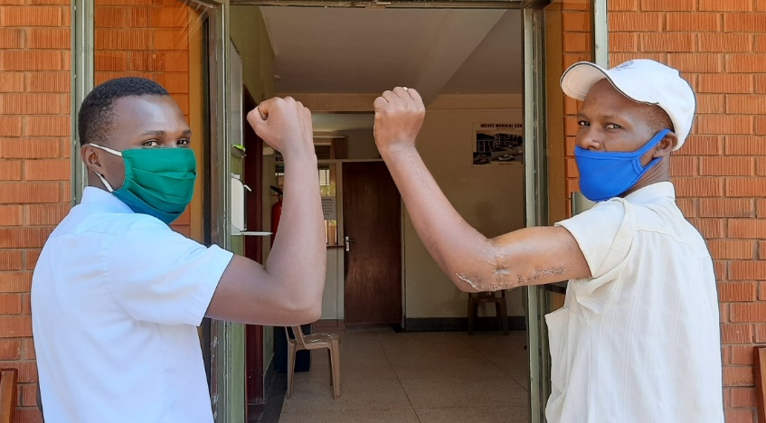

Before Surgery After Surgery
Ramathan broke his arm while working at a construction site in 2017. He was initially taken to a private hospital and eventually to a public hospital but in both places, the cost of the surgery of approx. USD 1200 and USD 250 respectively was way beyond his reach .He spent the following one and half years nursing a broken arm. In May 2020, during the COVID pandemic food relief distribution project he was referred to Wentz Medical Center by Africa Renewal Ministries where the entire cost of his orthopedic corrective surgery worth USD 1,300 was fully covered through Patient Assistance Fund. Ramathan is extremely thankful to Wentz for relieving him and his family of the physical, psychological and economic effects experienced since 2017.

Life saving treatment for a child with burns under PAF
- Cervical and breast Cancer Screening
On the 8th of March which is the international women’s day, we reached out to women with cancer screening and ultra-scan services. A total of 69 women were screened and of these 4 tested positive and were referred to Mulago referral Hospital for further management.54 of these women also received ultra sound-scan services. The Objective of this annual exercise is to promote early detection of breast and cervical cancers and thereby reducing deaths due to these cancers.

- Flood intervention project
The purpose of the flood project is to reduce the effects of flooding amongst the urban poor and thereby improving their welfare. A total of 1,235 gum boots and 650 Mosquito nets were distributed as per breakdown below;

- 493 pairs of adult boots distributed in Katoogo.
- 157 pairs of adult boots distributed in Kisenego.
- 412 pairs of children’s boots distributed in Katoogo.
- 138 pairs of children’s boots distributed in Kisenego.
- 383 mosquito nets distributed in Katoogo.
- 267 mosquito nets distributed in Kisenego.
- 35 pairs distributed to volunteers during boots and food distributions.

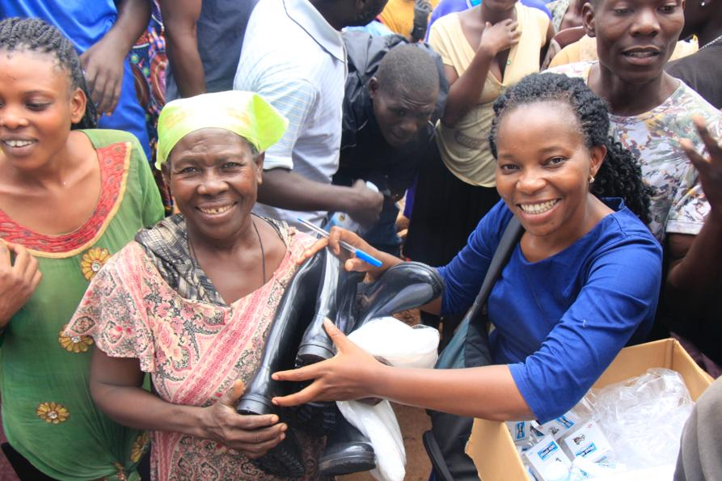
Distribution of boots, mosquito nets and deworming tablets in Katoogo
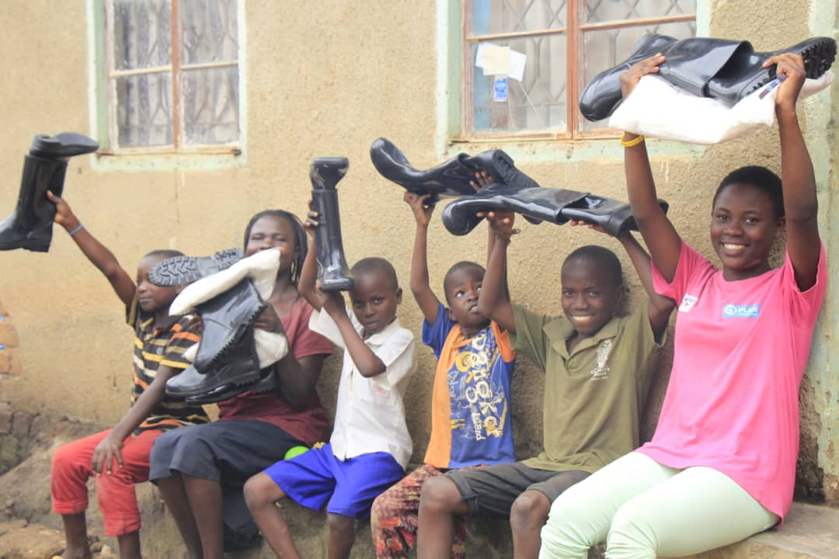
Distribution of boots and mosquito nets in Kisenego

- COVID 19 Response
Through partnership with Gaba Community Church and Africa Renewal Ministries, we managed to distribute food to 1,627 households and hand washing facilities to six villages of Gaba parish.

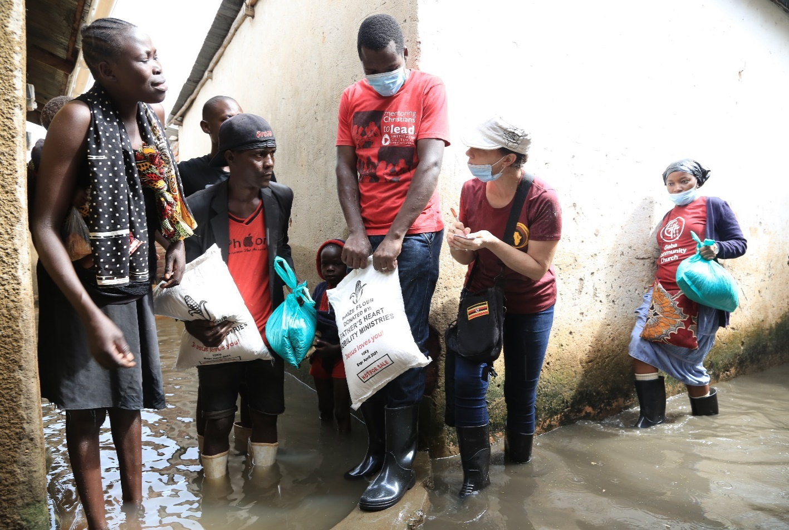
Food distribution in Kisenego

- Home visits
These are quarterly monitoring visits to interact with Health Access project beneficiaries about project deliverables and also assess current health needs in the communities.
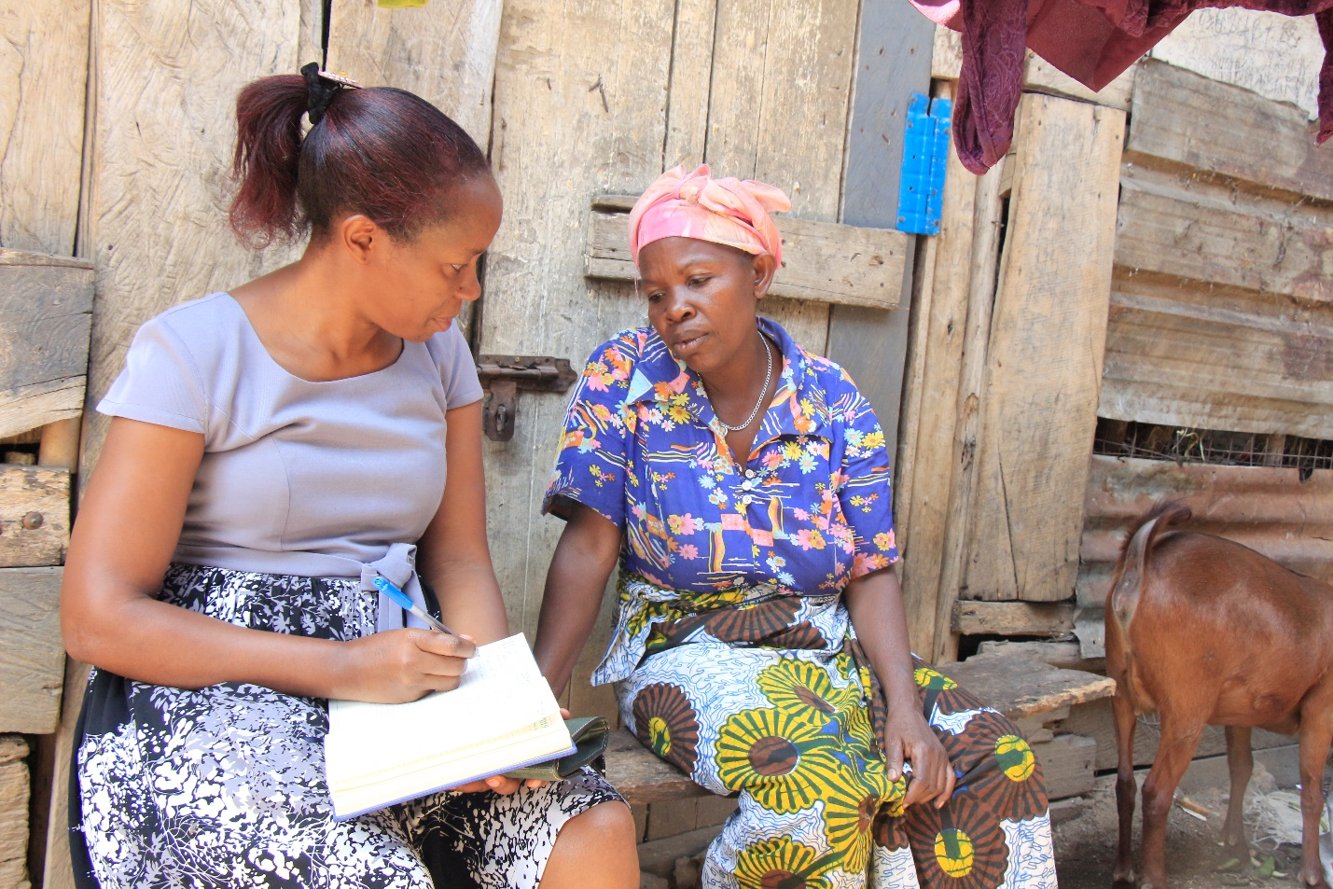
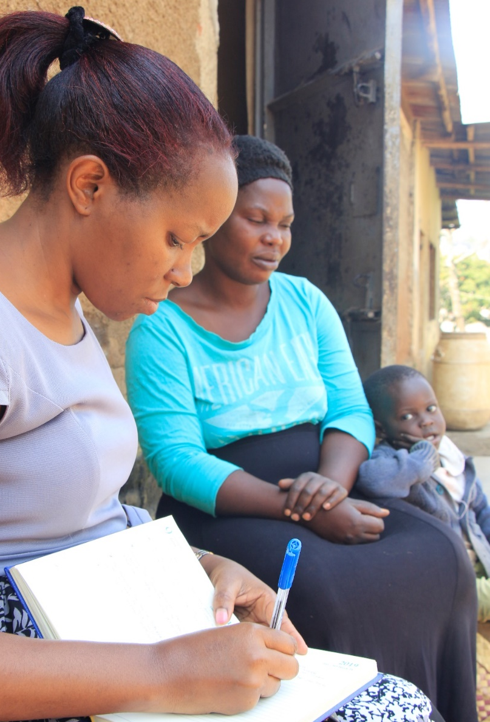

Interacting with some of the beneficiaries of Access Project in Katoogo and Kisenego respectively

Reports from home visits show increased utilization of healthcare services like immunization, screening, family planning, diagnostic and medical services which have reduced ill health in the communities of Katoogo and Kisenego.

Safe Motherhood –Isaac Fund

The main goal of the safe motherhood project is to improve the health of women during pregnancy, childbirth and the postpartum period through a comprehensive maternal health programme. The project specifically aims at reducing maternal and neonatal deaths in Katoogo and Kisenego by doing the following:
- Providing prenatal services to expectant mothers to enable them prevent complications and ensure a healthy pregnancy for every mother.
- Providing health education through the prenatal clinics to guarantee women the right to make informed decisions about their health before, during, and after pregnancy and childbirth.
- Ensuring safe deliveries for expectant mothers by skilled attendants.
Project Output
Six babies have been born under this project, five and one born through normal delivery and C-section respectively.
By the end of September, the project had registered fifteen pregnant women who are currently receiving prenatal services.

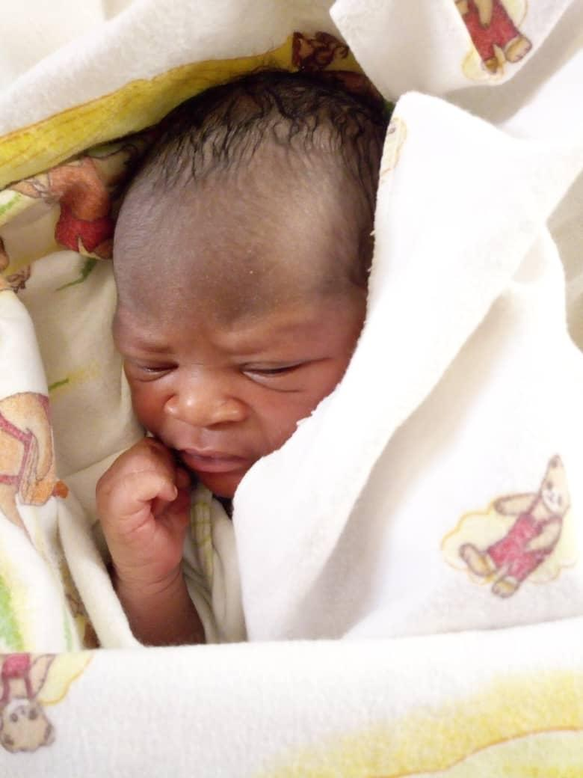

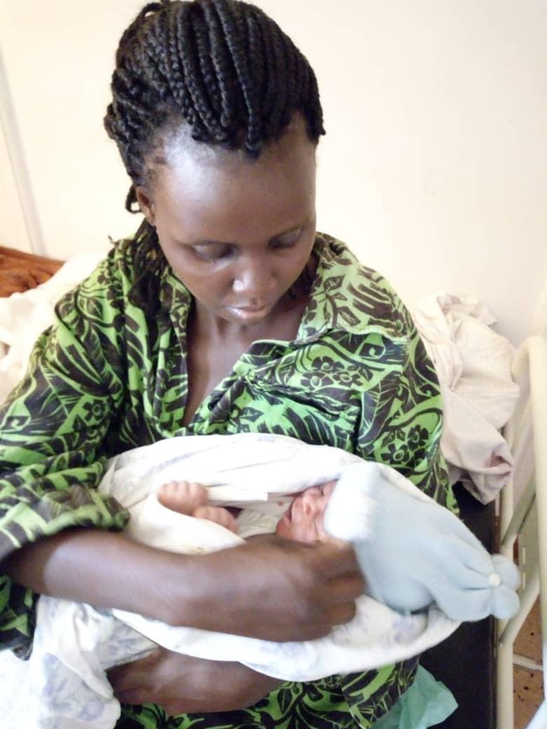

Katie and her baby: First beneficiary of safe motherhood-Isaac fund

Katie a mother of four children was our first safe motherhood project beneficiary. She narrated to us that this was her time to deliver under the care of skilled attendants. She told us that all her previous children were delivered with the help of traditional birth attendants(TBAs).
“With the monthly income of her husband of approx. $ 28 from roasting and selling groundnuts, giving birth in a private healthcare facility looked like a dream that could never be realized . I am very grateful to Wentz for such unbelievable acts of kindness and service. Your support provided much needed stress relief amidst effects of COVID 19.” Said Katie.

Lessons learned and good practices identified
- Village Health Teams (VHTs) continue to be an effective mechanism for community mobilization and receiving feedback for improving community health.
- Our outreaches have improved the health status of those living in Katoogo and Kisenego as evidenced by managed chronic cases, reduced medical emergencies and ill health.

Challenges | Recommendations
- Need for improved medical camping facilities like portable examination beds, foldable tables and screening tents | - Acquisition of mobile camping facilities.
- Patients unfamiliar with COVID 19 SOPs during outreaches | - Ongoing health education about COVID 19 SOPs by VHTs.
- Overwhelming need for Patient Assistance Fund (PAF) | - Resource mobilization for PAF, currently each member of the management team of Wentz is contributing a minimum of $2 monthly each towards PAF.
- Specialized services beyond Wentz’s capacity to provide and yet the cost is beyond the reach of the urban poor. | - Strategic partnerships with likeminded organizations to help these patients.  - Resource mobilization  - Facility expansion to ensure such services are provided at Wentz Medical Center (New block construction plans underway).

Financial Reporting

Wire transfers
Date | Description | Amount in $
December 2019 | CHT for Jan & Feb | 4,000
March 2020 | CHT for March & April | 4,000
March 2020 | Flood Project | 7,000
March 2020 | Safe Motherhood –Isaac Fund | 3,000
June 2020 | CHT for May & June | 4,000
August 2020 | CHT for July & August | 4,000
 | Total project fund | 26,000

Expenses from January to September 2020
Month | Description | Amount in UGX | Dollar at 3600
Jan 2020 | Community Medical Outreaches for January | 6,525,000 | 1,813
Feb 2020 | Community Medical Outreaches for February | 8,157,600 | 2,266
March 2020 | Cervical Cancer screening | 1,947,000 | 541
March 2020 | Community medical outreaches for March | 7,437,600 | 2,066
March 2020 | Flood intervention project | 25,255,000 | 7,015
Sept 2020 | Safe Motherhood medical bills -Isaac Fund from May-Sept | 4,571,600 | 1,270
Sept 2020 | Community Medical outreaches for September | 9,575,000 | 2,660
Jan-Sept 2020 | Case worker(Project Officer) salary for nine months | 6,950,790 | 1,931
Jan-Sept 2020 | Patient Assistance Fund (PAF) medical bills from Jan- Sept | 10,998,600 | 3,055
 | Total | 81,418,190 | 22,616

30th September | Balance B/F |  | 3,384

Of this balance $ 1,730 is for Safe motherhood and $ 1,654 is for Access Project (CHT)

Financial report narration

- Due to COVID 19 lockdown guidelines which restricted mass public gatherings we were unable to carry out community outreaches from April to August hence this accounts for the less funds spent on community outreaches.
- Higher costs of PAF medical bills because the sick from Katoogo and Kisenego were directly referred to Wentz during the time when we could not carry out community outreaches.
- Complying with COVID 19 standard operating procedures (SOPs) for carrying out community outreaches has increased the costs of running community outreaches. This is because of the following reasons;
- Use of fields instead of churches, this requires hire of tents, chairs and tables.
- Ensuring that there are sanitizers on every service center.
- Hand washing facilities
- Use of personal protective equipment like masks, disposable aprons and face shields.
- Use of security officers to ensure that patients comply with COVID 19 SOPs.

VI. Special Note of Appreciation
The success of Healthcare access to the urban poor is highly attributed to the active involvement and participation of member of the Village Health Team (VHT), healthcare service providers at Wentz, Access project team and the administration of Wentz Medical Center.
On behalf of Wentz Medical Center, I wish to convey our sincere appreciation to all partners for the support given to Access project. The dedication and hard work of every person on the team is commendable.
Specifically I convey our appreciation to World Water, thank you for the project funds, your generosity is a ray of hope for the urban poor who cannot afford quality healthcare. Thanks for being so selfless.
We look forward to future partnerships to improve community Health.

Compiled by Sarah,
Project Manager
Healthcare Access Project

